MAY 26 2016

Cleverman: ABC's Indigenous superheroes in eerie dystopian drama starring Iain Glen and Frances O'Connor


Lenny Ann Low

Standing on the balcony of a multimillion-dollar cliff-top mansion in Coogee, actor Iain Glen is surveying the crystal blue Pacific Ocean.
"I can see whales," he says, causing a roomful of TV technicians and actors to rush to the windows and an outside courtyard to watch two humpbacks, one with a column of water above its blowhole, glide past in sun-glinted water.
It is a beguilingly calm sight after the exquisitely tense dinner party scene the Glen has just filmed for new ABC TV genre drama series Cleverman.

The six-episode series, which starts on June 2 and also screens on BBC Three's newly-launched online platform and SundanceTV in the US, is an eerie, dystopian sci-fi TV drama series.
Featuring a mythological species, called the Hairypeople (or Hairies), a super-humanoid race who emerged from the Outback and live among humans, it is a new take on ancient indigenous stories.
Originally conceived by producer and writer Ryan Griffen, it explores modern humans' extreme prejudice against the Hairies, a minority with extraordinary strength, speed and longevity, who are battling for their survival.
Glen signed up to the production after reading just two scripts.
"It was fantastic writing," he says. "And it felt like an important subject and [one that is] probably not dealt with enough.
"I think what Cleverman does is a very different look at it, a very brutally honest look at some of the things that took place [in Australia's history], but in a setting of the future."

Glen is Jarrod Slade, a wealthy self-made businessman and CEO of Slade Industries, who is an educated and approachable type (think Richard Branson), who appears to want to help the Hairies but may have an ulterior motive.
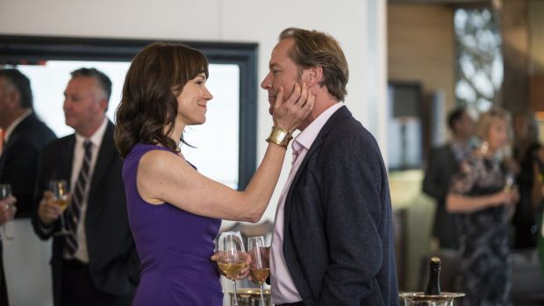

Iain Glen, as Jarrod Slade, and Frances O'Connor, as his wife, Charlotte Slade, in ABC TV's Cleverman. Photo: ABC
Facing him edgily at the dinner party is Waaru West (played by Rob Collins), the self-appointed leader of the Hairies, and the estranged brother of Koen (Hunter Page-Lochard), who has, to Waaru's fury, inherited special abilities making him a Cleverman, a healer and a conduit between the Dreaming and the present.
Directed by Wayne Blair (The Sapphires) and Leah Purcell (Redfern Now, Janet King), Cleverman follows how a series of murders in the city sparks authorities to clamp down on runaway Hairies from The Zone, where the poor and vulnerable live.

In this controlled ghetto-like area, patrolled by the Containment Authority, the Hairies have found a haven from being hunted down as sub-humans in the city.
While Koen struggles to deal with his new destiny, he and his older brother, Waaru, must find a way to unite and save their culture.
Filmed on locations including the rail sheds of Redfern and the former cliff-top home of advertising titan John Singleton in Coogee. Cleverman has an 80 per cent Indigenous cast, including Deborah Mailman (The Sapphires), Collins (The Lion King), Jack Charles and rapper Briggs, who also contributes to the series' score.

It also features Frances O'Connor (The Missing, Mr Selfridge) as Slade's wife, Charlotte, a morally-focused doctor who does pro-bono work in the Zone, and Stef Dawson of The Hunger Games.

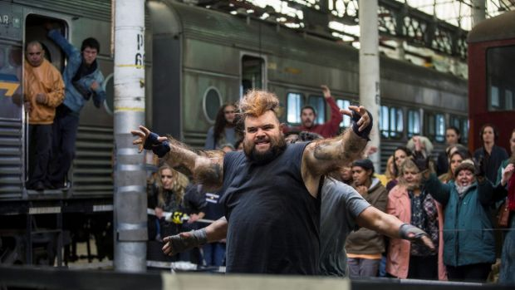
The inhabitants of The Zone in Cleverman. Maliyan (Adam Briggs), a Hairy, is at front. Photo: ABC

Griffen spent five years respectfully and sensitively gathering stories from elders in Indigenous communities in NSW and the Northern Territory. The idea began as a children's story but Griffen, with Goalpost producer Rosemary Blight, soon realised it was a genre drama for an adult audience.
"The original idea for Cleverman came to me over a weekend while I was playing dress-ups with my son," Griffen says. "Both of his parents are light-skinned Aboriginals and it was about finding a way to bring culture to him but also bringing the love of superheroes. He loves Batman, Ninja Turtles, all that sort of stuff, as do I."

Blight says it is very rare for such a distinct and compelling idea to be offered nowadays.
"We said: 'OK, let's give it a go, that sounds absolutely nuts'," she says. "What appealed was the idea was from a young Aboriginal-Australian voice, which is again very rare. And also that Ryan is a sort of pop culture, geeky guy, who brings something that we don't often do in this country.
"We do drama very, very well but this was a bolt of fresh storytelling. Very rarely does someone walk in the door and say: 'From the stories that I grew up with, I'm going to take these stories and put them into a super-power world, of X-Men, Superman'.
"It was simply: 'Wow, I've never heard of that before'. And we live in a world where there is so much drama that, in concept, we have seen time and time again."
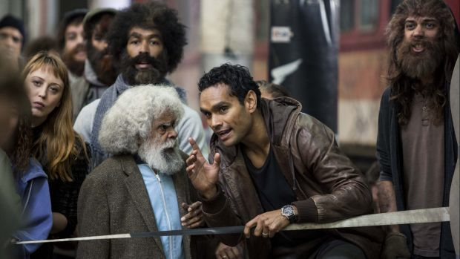
Uncle Jimmy (Jack Charles) and Waaru (Rob Collins) in Cleverman. Photo: ABC TV

Cleverman, Griffen says, is a new way of telling Indigenous stories.

"We're telling ancient stories but putting a twist on them that's universal," he says. "The benefit of that is that even in our own country, a lot of people don't know our stories."
For years, Blight says, broadcasters have been asking for the Australian equivalent of Merlin or The Walking Dead.

"But the Knights of the Round Table, or Harry Potter are not our stories," she says. "And what are our stories? Cleverman is our stories. And these stories have been here 60,000 yers and they've just been waiting to be told by the right people, by the people who are the keepers of the stories."

Griffen says talking to elders, seeking permission and explaining how the stories will be told in Cleverman, was a necessarily big task.

"They needed to know they could trust us with telling, and being true to them," he says. "But also allow them to be told in a more modern sense.
"Otherwise these stories will be lost. When more people become more interested in it, the more vibrant and alive it becomes again."
WHAT Cleverman

WHEN ABC and ABC iview, June 2 at 9.30pm

